A PROJECT REPORT

**DSED 04 AGILE PROJECT**

**A MOBILE APPLICATION: TO DO APP**

SUBMISSION DATE: JUN 13, 2021

|  |  |
| --- | --- |
| **SUBMITTED BY** | **SUBMITTED TO** |
| AKASHDEEP SINGH | BIKASH POKHREL |
| CHARANJEET SINGH | IT TUTOR |
| SAHIL |  |
| SURBHI |  |

**About the APP**

This application is made on Xamarin using C# as an object oriented programming language. The purpose of the application is to have an android application that can create and delete any task and including the date of the task to be executed.

**Features of the app**

* Interactive user interface
* Intuitive and simple design
* Good use of color combination
* Low memory sized application taking low phone resources
* Can be used for anyone to manage their tasks

**Timeline:**

|  |  |  |  |
| --- | --- | --- | --- |
| SN | Task | Expected time | Final time |
| 1. | Collecting the requirement | 2 days | 2 days |
| 2. | Discussion on agile and scrum tools among team | 3 days | 4 days |
| 3. | Designing the template | 2 days | 3 days |
| 4. | Coding backend | 2 days | 2 days |
| 5. | Deploying and checking the errors | 3 hours | 5 hours |
| 6. | Documentation | 4 hours | 2 hours |
| 7. | Git Hub | 30 minutes | 20 minutes |
| 8. | Preparing for the presentation | 2 hours | 2 hours |

**Emulator requirement:**



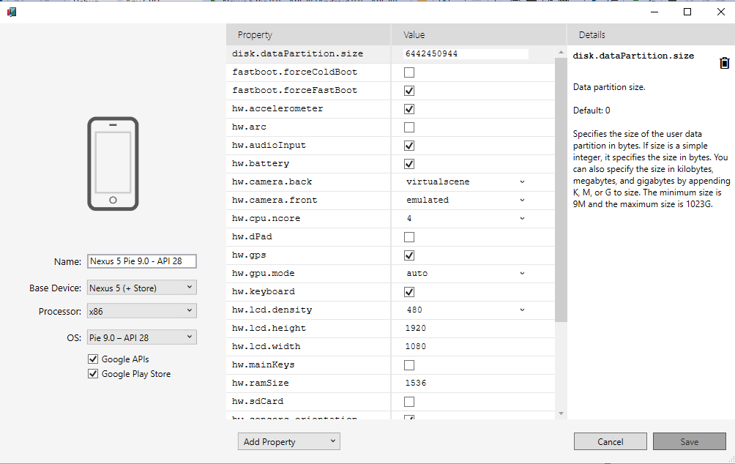

Screen1:

Username: surbhi

Password: surbhi

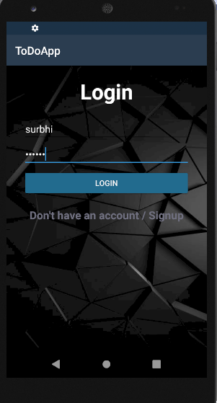

**Screen 2**

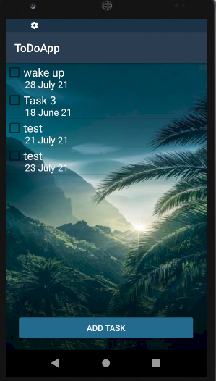

**Screen 3**

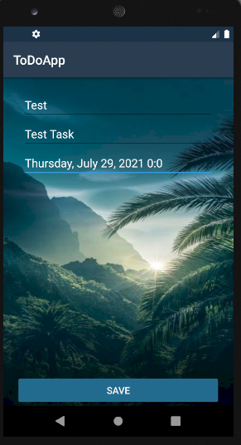



**Coding:**

Home.cs:

using Android.App;

using Android.OS;

using Android.Support.V7.App;

using Android.Runtime;

using Android.Widget;

using System;

using ToDoApp.Resources.Moldels;

using Android.Content;

using System.Collections.Generic;

namespace ToDoApp

{

//this is coding for the for the home screen of the To do app

[Activity(Label = "@string/app_name", Theme = "@style/AppTheme")]

public class home : AppCompatActivity

{

//this is class and provided the list view

ListView lstViewData;

Android.Graphics.Color a = Android.Graphics.Color.SlateGray;

List<Resources.Moldels.Task> listSource = new List<Resources.Moldels.Task>();

Android.Widget.Button add;

Database db;

protected override void OnCreate(Bundle savedInstanceState)

{

base.OnCreate(savedInstanceState);

Xamarin.Essentials.Platform.Init(this, savedInstanceState);

SetContentView(Resource.Layout.tasks);

db = new Database();

db.createDatabase();

lstViewData = FindViewById<ListView>(Resource.Id.listView);

LoadData();

add = FindViewById<Button>(Resource.Id.btnAdd);

add.Click += new EventHandler(Btntest1_Clicked);

lstViewData.ItemLongClick += (s, e) =>

{

Android.App.AlertDialog.Builder dialo = new Android.App.AlertDialog.Builder(this);

Android.App.AlertDialog alert = dialo.Create();

alert.SetMessage("Select an option");

alert.SetButton("Delete", (c, ev) => {

db.removeTable( e.Id );

LoadData();

});

alert.SetButton2("Cancel", (c, ev) => {

base.OnBackPressed();

});

alert.Show();

};

lstViewData.ItemClick += (s, e) =>

{

for (int i = 0; i <= lstViewData.Count; i++)

{

if (e.Position == i)

{

var t = e.View.FindViewById<CheckBox>(Resource.Id.listTask);

t.Tag = e.Id;

if (t.Checked==true)

{

t.Checked = false;

db.updateStatus(e.Id, t.Checked);

}

else

{

t.Checked = true;

db.updateStatus(e.Id, t.Checked);

}

}

}

};

}

private void Btntest1_Clicked(object sender, EventArgs e)

{

Intent intent = new Intent(this, typeof(tasks));

StartActivity(intent);

}

private void Btntest2_Clicked(object sender, EventArgs e)

{

Toast.MakeText(Application.Context, "Invalid Login / Username", ToastLength.Short).Show();

}

private void LoadData()

{

listSource = db.selectTable();

try

{

var adapter = new ListViewAdapter(this, listSource);

lstViewData.Adapter = adapter;

}

catch (NullReferenceException ex)

{

Console.WriteLine("Error");

}

}

}

}

**MainActivity.cs**

using Android.App;

using Android.OS;

using Android.Support.V7.App;

using Android.Runtime;

using Android.Widget;

using System;

using ToDoApp.Resources.Moldels;

using Android.Content;

using System.Collections.Generic;

namespace ToDoApp

//for the main activity of the app

{

[Activity(Label = "@string/app_name", Theme = "@style/AppTheme", MainLauncher = true)]

public class MainActivity : AppCompatActivity

{

Android.Widget.EditText user;

Android.Widget.EditText pswd;

Android.Widget.Button btn;

Android.Widget.TextView btnSign;

Database db;

List<Resources.Moldels.User> listSource = new List<Resources.Moldels.User>();

protected override void OnCreate(Bundle savedInstanceState)

{

base.OnCreate(savedInstanceState);

Xamarin.Essentials.Platform.Init(this, savedInstanceState);

SetContentView(Resource.Layout.activity_main);

db = new Database();

db.createDatabase();

user = FindViewById<EditText>(Resource.Id.editUser);

pswd = FindViewById<EditText>(Resource.Id.editPswd);

btn = FindViewById<Button>(Resource.Id.btnLogin);

btn.Click += new EventHandler(Btntest1_Clicked);

btnSign = FindViewById<TextView>(Resource.Id.txtSign);

btnSign.Click += new EventHandler(Btntest2_Clicked);

}

private void Btntest1_Clicked(object sender, EventArgs e)

{

String usr = user.Text.ToString();

String pwd = pswd.Text.ToString();

listSource = db.checkUser(usr,pwd);

if (usr.Equals("admin") && pwd.Equals("12345"))

{

Intent intent = new Intent(this, typeof(home));

StartActivity(intent);

}

else if(listSource.Count!=0)

{

// try

//{

// Console.WriteLine("Elemtnts ->" + listSource[0].ToString());

Intent intent = new Intent(this, typeof(home));

StartActivity(intent);

/* }

catch (NullReferenceException ex)

{

Toast.MakeText(Application.Context, "Invalid Login / Username", ToastLength.Short).Show();

}

*/

}

else

{

Toast.MakeText(Application.Context, "Invalid Login / Username", ToastLength.Short).Show();

}

}

private void Btntest2_Clicked(object sender, EventArgs e)

{

Intent intent = new Intent(this, typeof(signup));

StartActivity(intent);

}

public override void OnRequestPermissionsResult(int requestCode, string[] permissions, [GeneratedEnum] Android.Content.PM.Permission[] grantResults)

{

Xamarin.Essentials.Platform.OnRequestPermissionsResult(requestCode, permissions, grantResults);

base.OnRequestPermissionsResult(requestCode, permissions, grantResults);

}

}

}

**Signup.cs**

using Android.App;

using Android.OS;

using Android.Support.V7.App;

using Android.Runtime;

using Android.Widget;

using System;

using ToDoApp.Resources.Moldels;

using Android.Content;

using System.Collections.Generic;

namespace ToDoApp

{

[Activity(Label = "@string/app_name", Theme = "@style/AppTheme")]

//the signup is done with this class

public class signup : AppCompatActivity

{

Android.Widget.EditText userTxt;

Android.Widget.EditText pswdTxt;

Android.Widget.Button signBtn;

Android.Widget.TextView loginBtn;

Database db;

protected override void OnCreate(Bundle savedInstanceState)

{

base.OnCreate(savedInstanceState);

Xamarin.Essentials.Platform.Init(this, savedInstanceState);

SetContentView(Resource.Layout.signUP);

db = new Database();

db.createDatabase();

userTxt = FindViewById<EditText>(Resource.Id.signUser);

pswdTxt = FindViewById<EditText>(Resource.Id.signPswd);

signBtn = FindViewById<Button>(Resource.Id.btnSignup);

signBtn.Click += new EventHandler(Btntest1_Clicked);

loginBtn = FindViewById<TextView>(Resource.Id.txtLogin);

loginBtn.Click += new EventHandler(Btntest2_Clicked);

}

private void Btntest1_Clicked(object sender, EventArgs e)

{

String usr = userTxt.Text.ToString();

String pwd = pswdTxt.Text.ToString();

if (usr!="" && pwd != "")

{

Resources.Moldels.User newUser = new Resources.Moldels.User()

{

user = usr,

pswd = pwd

};

db.insertIntoUser(newUser);

Intent intent = new Intent(this, typeof(home));

StartActivity(intent);

}

else

{

Toast.MakeText(Application.Context, "Invalid Username / Password", ToastLength.Short).Show();

}

}

private void Btntest2_Clicked(object sender, EventArgs e)

{

Intent intent = new Intent(this, typeof(MainActivity));

StartActivity(intent);

}

}

}

**Tasks.cs**

using Android.App;

using Android.OS;

using Android.Support.V7.App;

using Android.Runtime;

using Android.Widget;

using System;

using ToDoApp.Resources.Moldels;

using Android.Content;

using System.Collections.Generic;

namespace ToDoApp

{

[Activity(Label = "@string/app_name", Theme = "@style/AppTheme")]

//the tasks are added to the list

public class tasks : AppCompatActivity

{

Android.Widget.EditText t;

Android.Widget.EditText n;

Android.Widget.Button addBtn;

Android.Widget.EditText dueBtn;

Android.Widget.Button remindBtn;

Database db;

protected override void OnCreate(Bundle savedInstanceState)

{

base.OnCreate(savedInstanceState);

Xamarin.Essentials.Platform.Init(this, savedInstanceState);

SetContentView(Resource.Layout.addTask);

db = new Database();

db.createDatabase();

t = FindViewById<EditText>(Resource.Id.txtTask);

n = FindViewById<EditText>(Resource.Id.txtNote);

addBtn = FindViewById<Button>(Resource.Id.btnDone);

addBtn.Click += new EventHandler(Btntest1_Clicked);

dueBtn = FindViewById<EditText>(Resource.Id.btnDue);

dueBtn.Click += (sender, e) =>

{

DateTime today = DateTime.Today;

DatePickerDialog dialog = new DatePickerDialog(this, onDateSet, today.Year, today.Month - 1, today.Day);

dialog.DatePicker.MinDate = today.Millisecond;

dialog.Show();

};

// dueBtn.Click += new EventHandler(Btntest2_Clicked);

// remindBtn = Find()ViewById<Button>(Resource.Id.btnRemind);

// remindBtn.Click += new EventHandler(Btntest3_Clicked);

}

void onDateSet(object sender,DatePickerDialog.DateSetEventArgs e)

{

dueBtn.Text = e.Date.ToLongDateString();

DateTime today = DateTime.Today;

TimePickerDialog dialog = new TimePickerDialog(this, onTimeSet, today.Hour, today.Minute - 1, false);

dialog.Show();

}

void onTimeSet(object sender, TimePickerDialog.TimeSetEventArgs ex)

{

dueBtn.Text = dueBtn.Text+" " + ex.HourOfDay+":"+ex.Minute;

}

private void Btntest1_Clicked(object sender, EventArgs e)

{

if (t.Text != "")

{

Resources.Moldels.Task newUser = new Resources.Moldels.Task()

{

title=t.Text.ToString(),

note= n.Text.ToString(),

dueDate= Convert.ToDateTime(dueBtn.Text.ToString()),

remindDate= Convert.ToDateTime(dueBtn.Text.ToString()),

status=false

};

db.insertIntoTable(newUser);

Toast.MakeText(Application.Context, "Task Saved Successfuly", ToastLength.Short).Show();

}

else

{

Toast.MakeText(Application.Context, "Enter Task", ToastLength.Short).Show();

}

}

private void Btntest2_Clicked(object sender, EventArgs e)

{

}

private void Btntest3_Clicked(object sender, EventArgs e)

{

}

}

}